**Project Title**

Salesforce Developer Project to Supply Leftover Food to the Poor

**Submitted by**

**GANTLA VINDHYA**

**Roll Number:   21131A05D1**

**Gayatri Vidya Parishad College of Engineering(A), Visakhapatnam**

**Email I’d: -** [**21131A05D1@gvpce.ac.in**](mailto:21131A05D1@gvpce.ac.in)

**1. Project Overview**

This project is focused on reducing food waste and addressing hunger by developing a system using Salesforce technology. The goal is to connect restaurants, grocery stores, and food suppliers with non-profit organizations to facilitate efficient distribution of surplus food to those in need. Leveraging Salesforce CRM as the platform’s backbone, the project aims to enhance operational efficiency, automate logistics, and ensure real-time tracking of food donations and deliveries, thus supporting the mission to reduce food insecurity.

**2. Objectives**

**Business Goals**:

* Minimize food waste by streamlining the donation process.
* Alleviate hunger by efficiently distributing surplus food.

**Specific Outcomes**:

* Develop a network for donors and recipients.
* Automate matching processes based on location, food type, and urgency.
* Ensure timely and transparent tracking and delivery of food donations.

**3. Salesforce Key Features and Concepts Utilized**

This project utilizes several core Salesforce functionalities:

* **Objects**: Both standard (e.g., Accounts, Contacts) and custom objects were created to handle specific requirements for food donations, recipients, and logistics.
* **Tabs**: Custom tabs were developed to access and manage various objects, including Venues, Drop-Off Points, and Volunteers.
* **Fields**: Custom fields within objects capture essential data, such as contact information, task details, and volunteer schedules.
* **Flows**: Automation flows guide processes, ensuring seamless record creation and updates.
* **Triggers**: Apex triggers enforce custom business rules and actions within the system.
* **Profiles**: Defined user permissions for different roles to ensure secure access.
* **Users**: Added users with specific roles and permissions to manage activities within the application.
* **Public Groups**: Created to manage permissions and data visibility effectively.
* **Report Types and Dashboards**: Generated custom reports and dashboards to visualize key metrics for decision-making and track progress.

**4. Detailed Steps to Solution Design**

**salesforce developer account creation**

Creating a developer org in salesforce and Account Activation

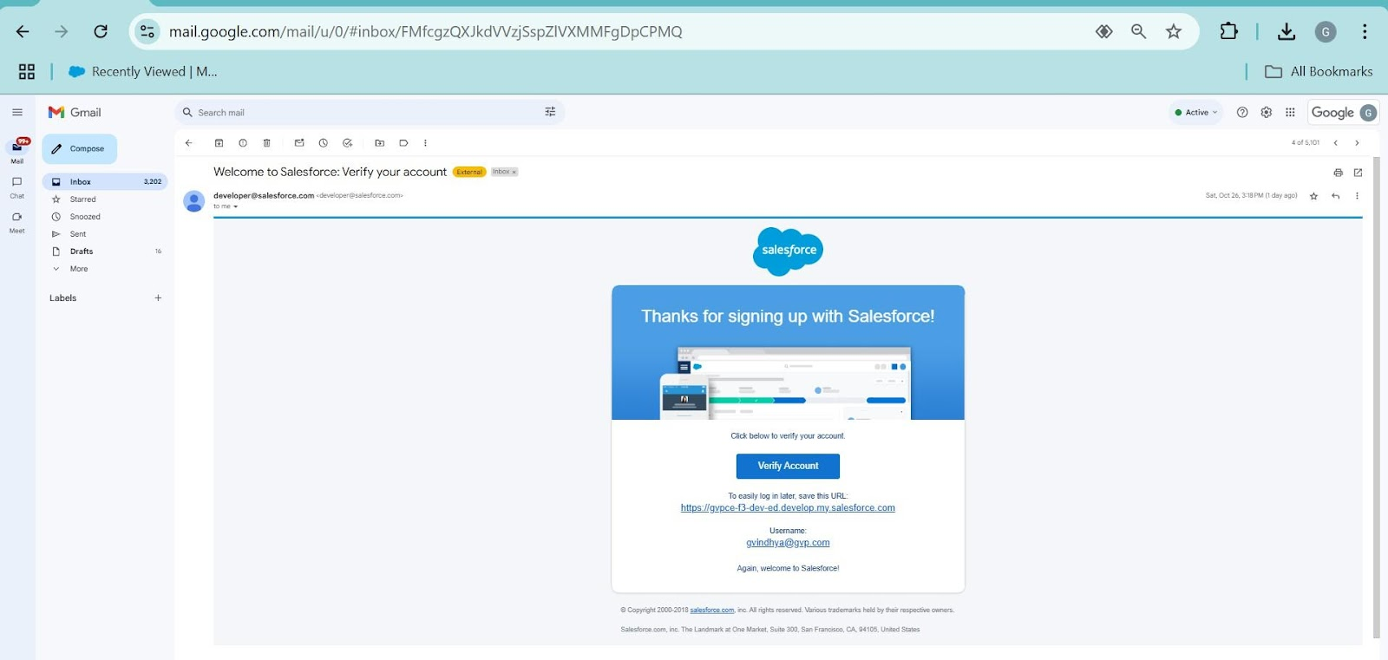

**Object**

In Salesforce, an object is a database table that stores data related to a specific entity, such as customers, products, or sales transactions. Objects are the building blocks of Salesforce data models.

There are two types of objects in Salesforce:

1. **Standard Objects:** These are pre-built objects provided by Salesforce, such as Accounts, Contacts, Leads, and Opportunities, which cover common business processes.

1. **Custom Objects:** These are user-defined objects created to store data unique to a particular business or application. Custom objects can have custom fields, relationships, and custom logic through workflows and triggers.

Objects are essential for organizing and managing data within the Salesforce platform. To create an object:

Here, We have Created All the objects which where asked.

1. Drop-Off Point

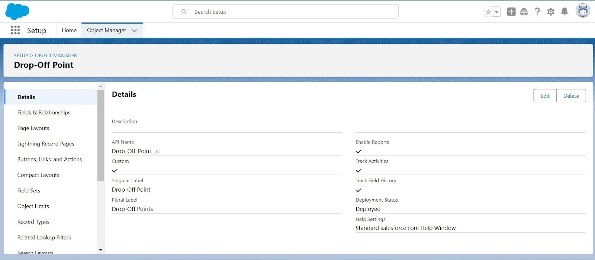

1. Task

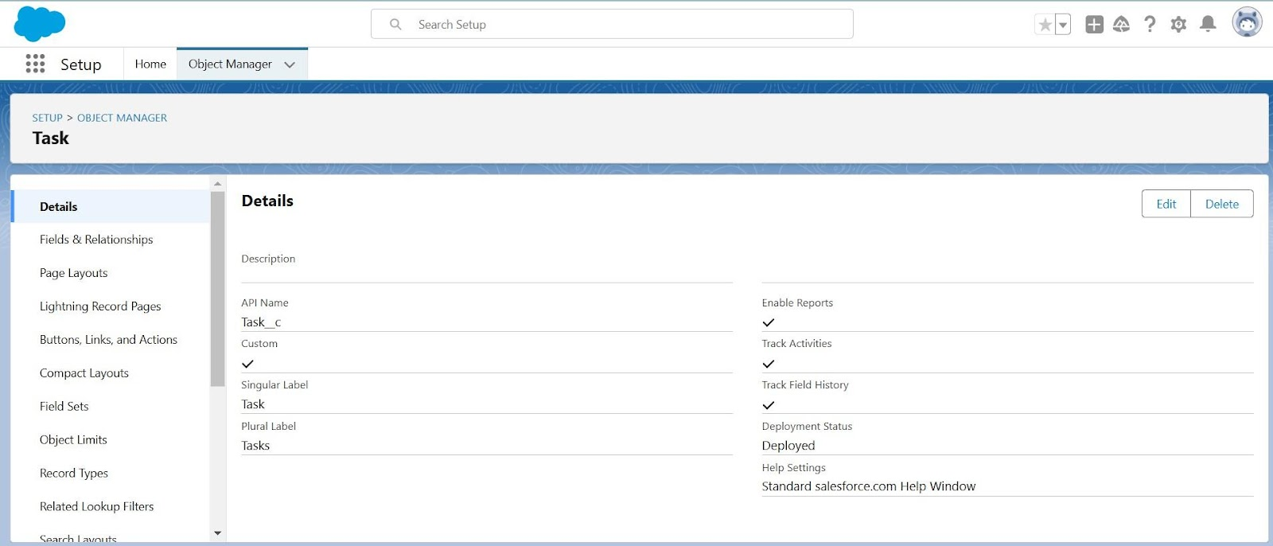

  3.Execution Details

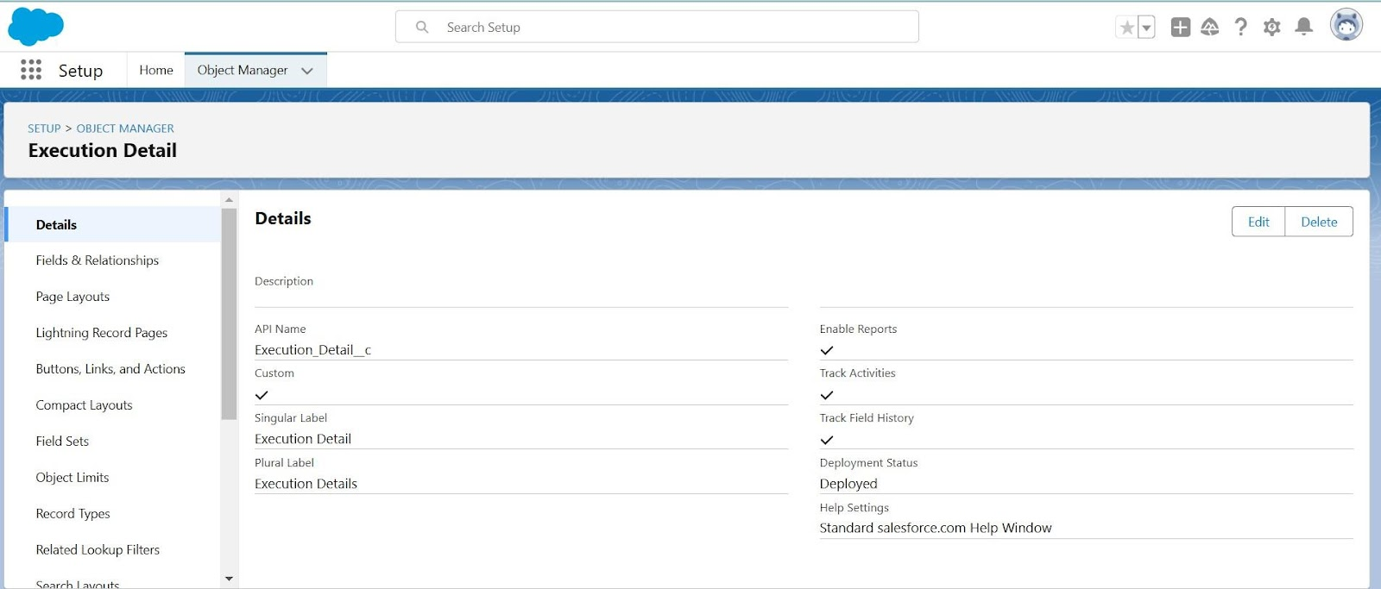

  4.Volunteer

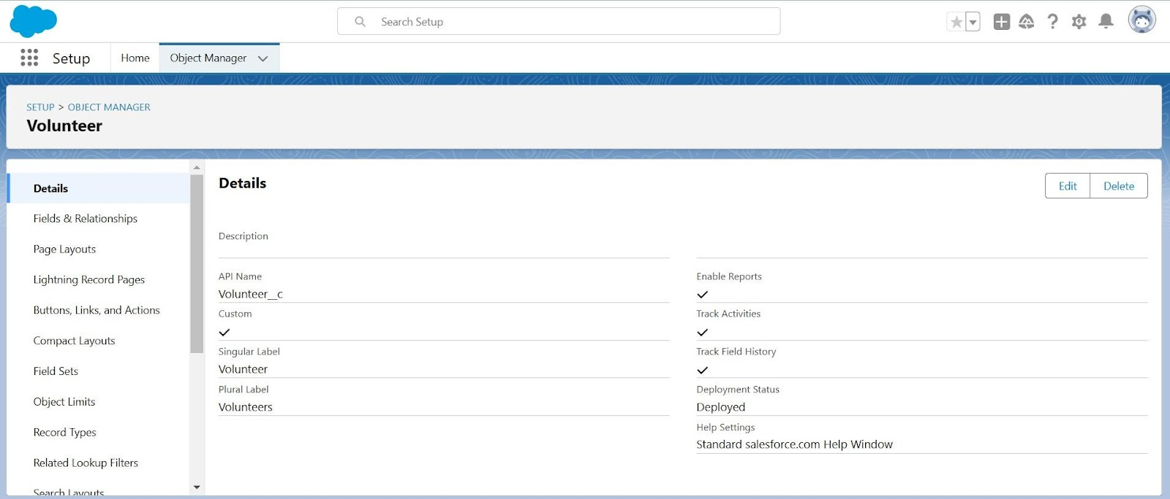

5.Venue

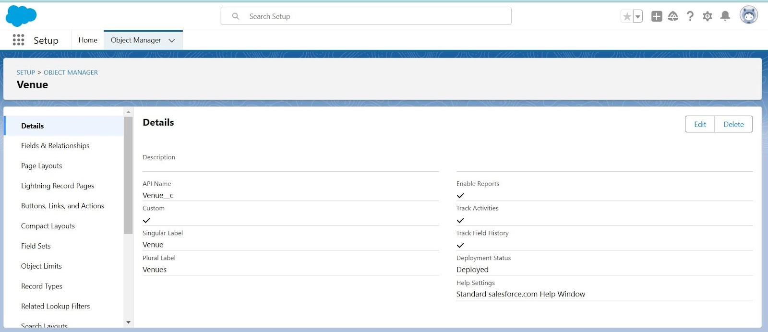

**Tabs**

What is Tab ?

A tab is like a user interface that is used to build records for objects and to view the records in the objects.

* **Creating a Custom Tab**

**Create Venues Tab**

1. Drop-Off Point Tab

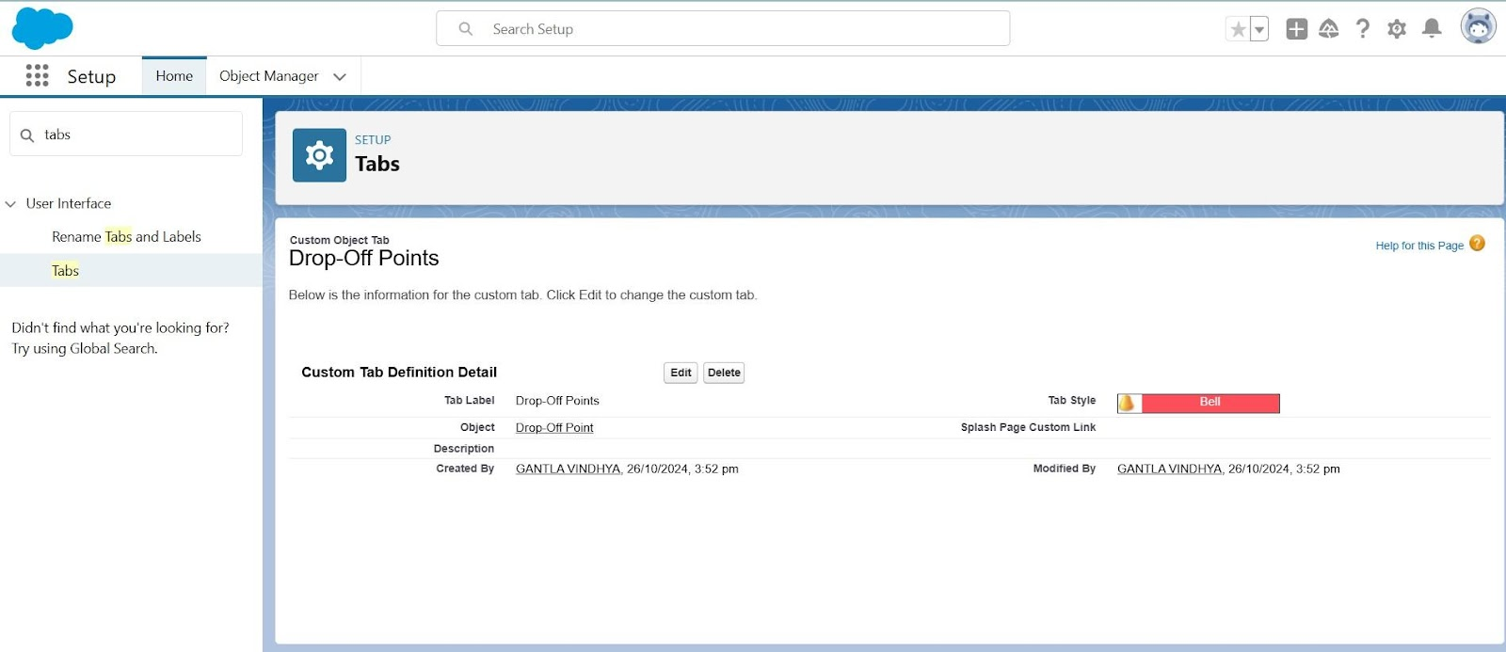

1. Execution Details Tab

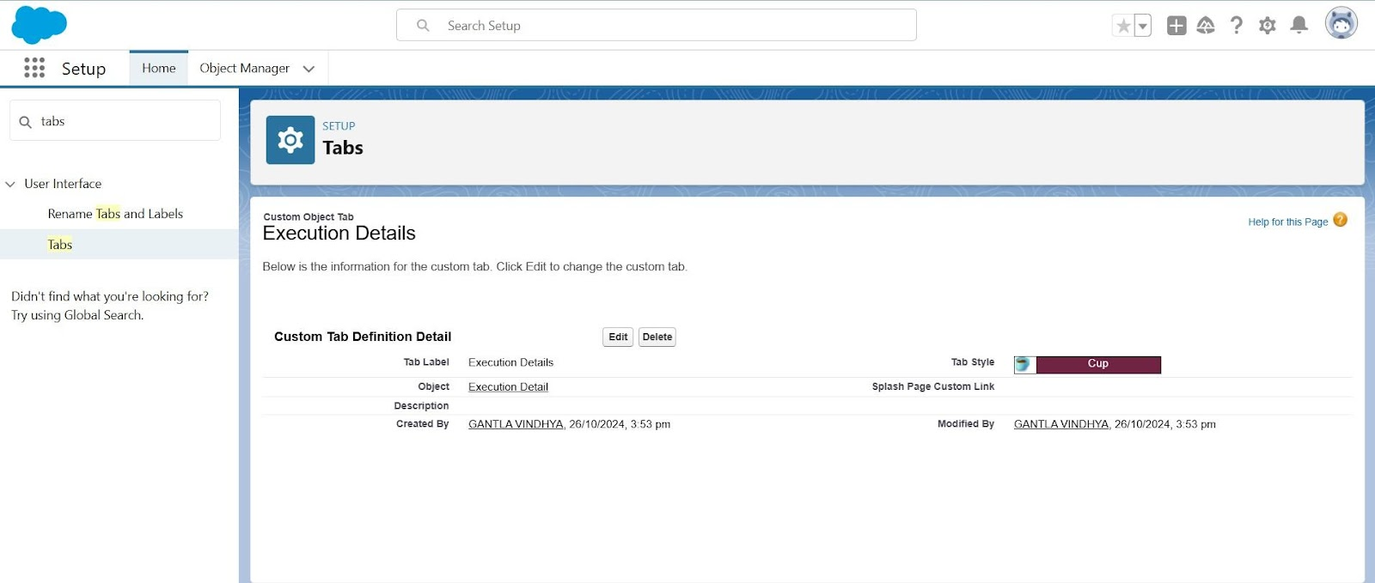

1. Venues Tab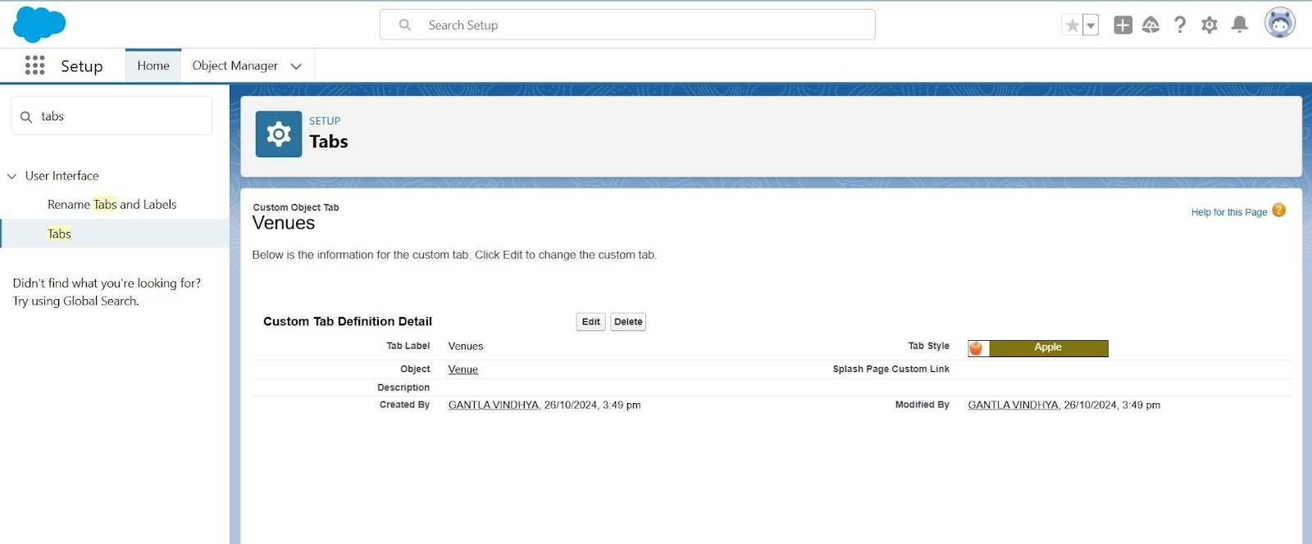
2. Volunteers Tab  
   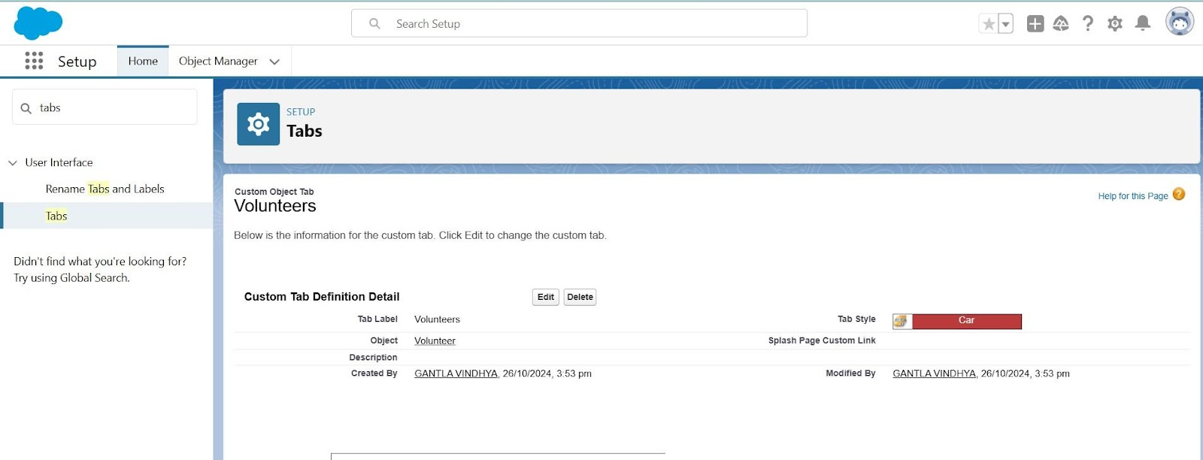

**Create a Lightning App**

**Will create a lightning app page-**

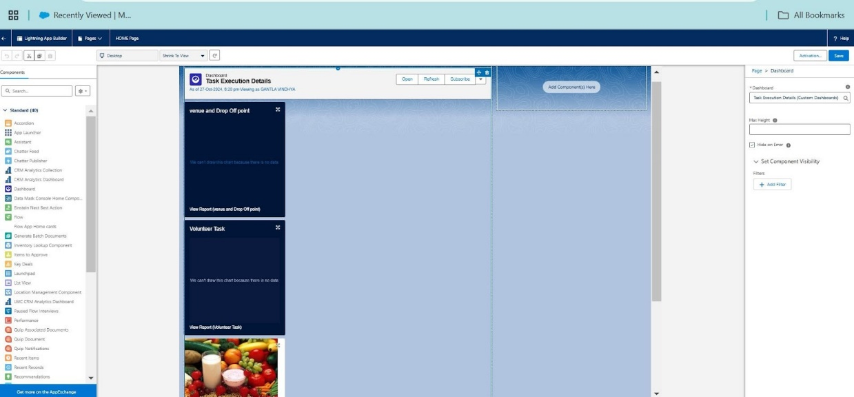

**Fields**

**What is a Field?**

Fields are specific data points within an object where individual pieces of information are stored. They are akin to columns in a database table and can hold various types of data, such as text, numbers, or dates.

Creation of Fields for the Volunteer Object - Gender

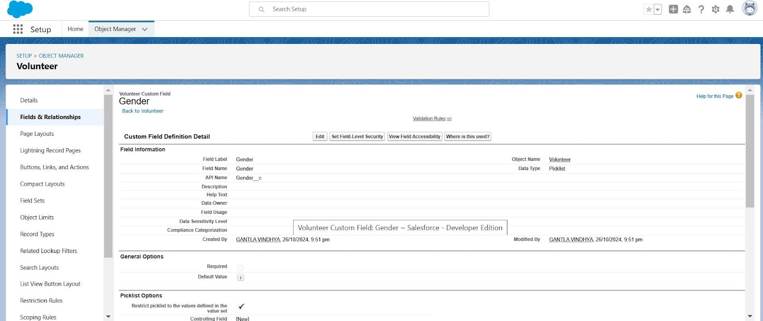

Execution ID

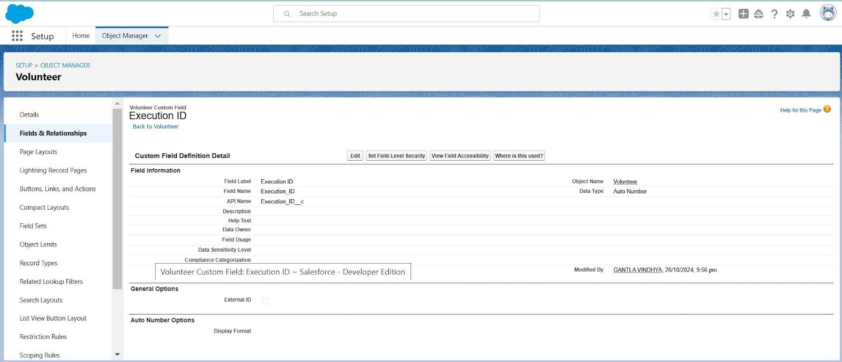

Date of birth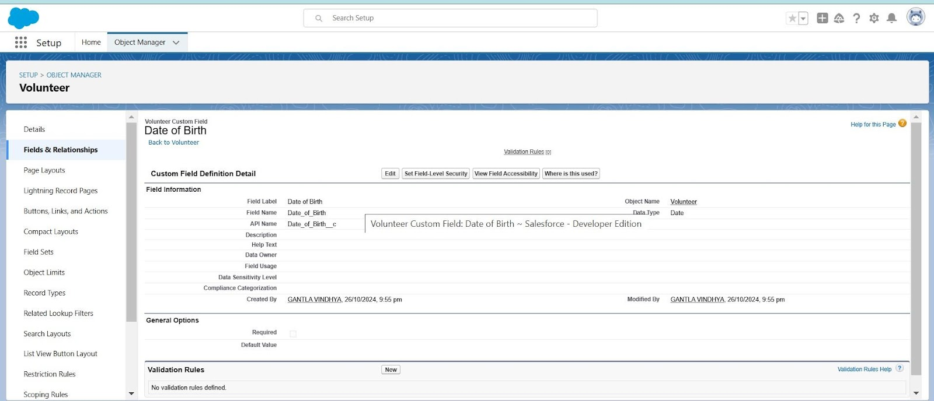

Addresss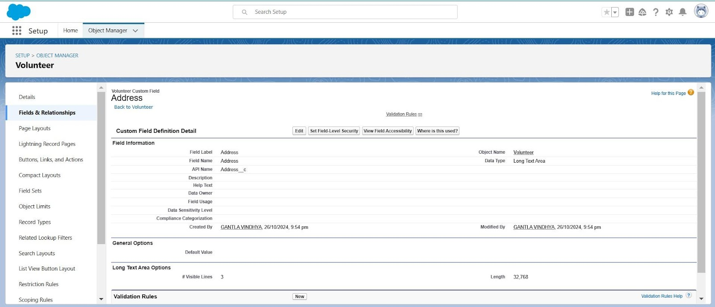

Email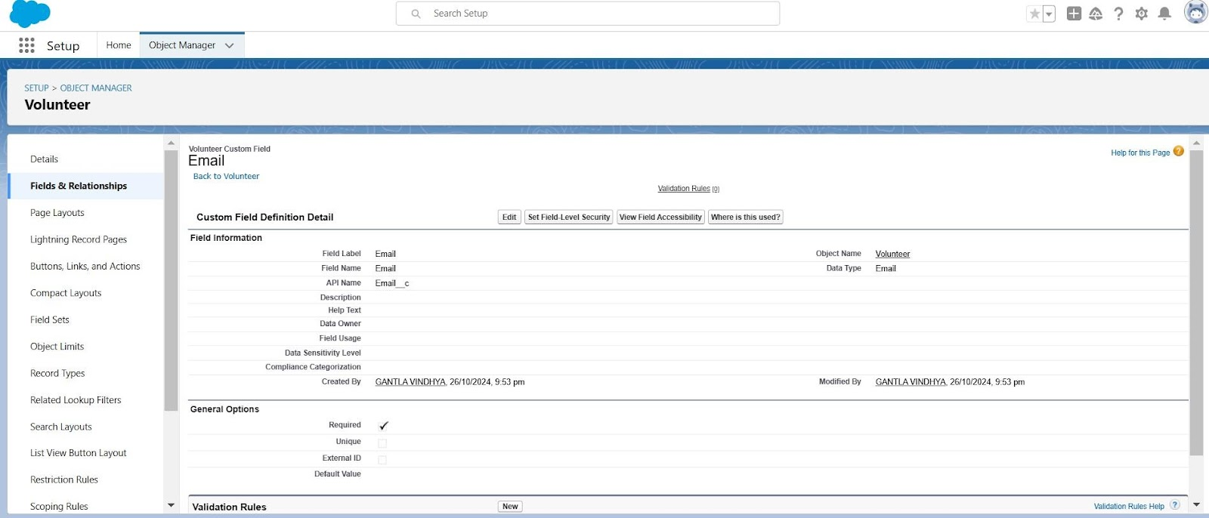

Age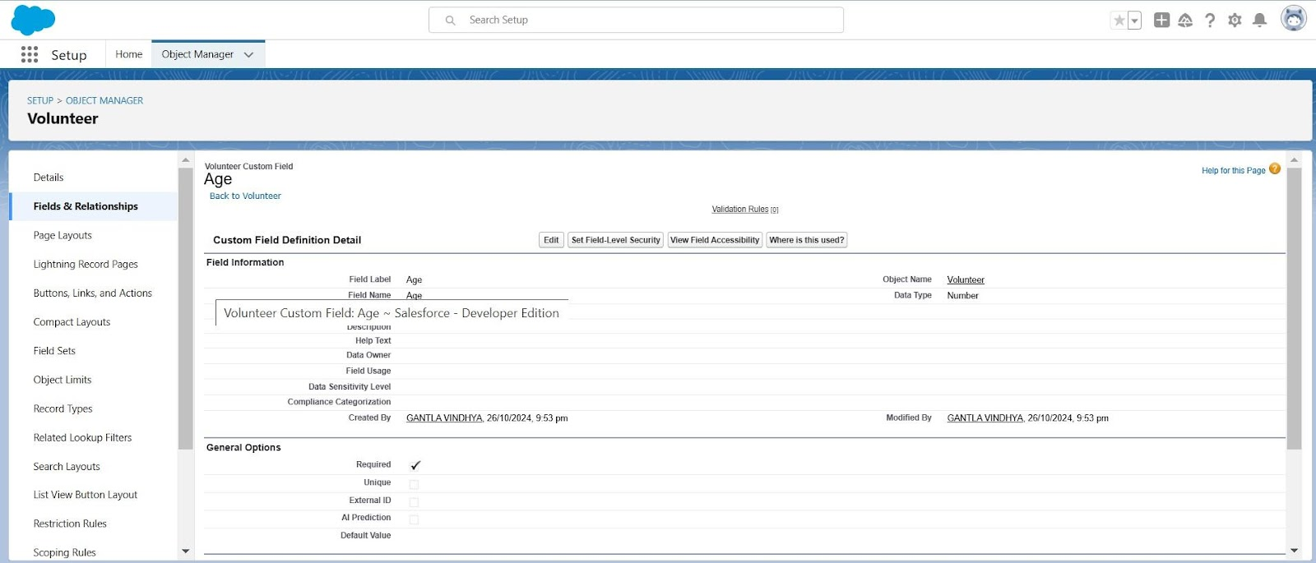

Avaialble On

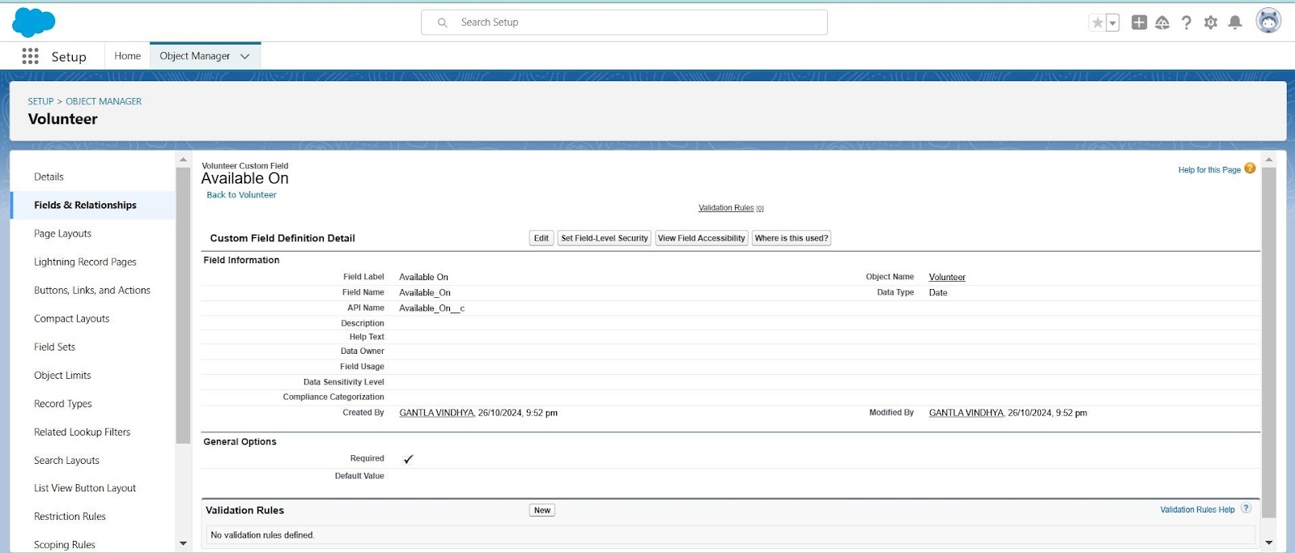

Drop_off_point

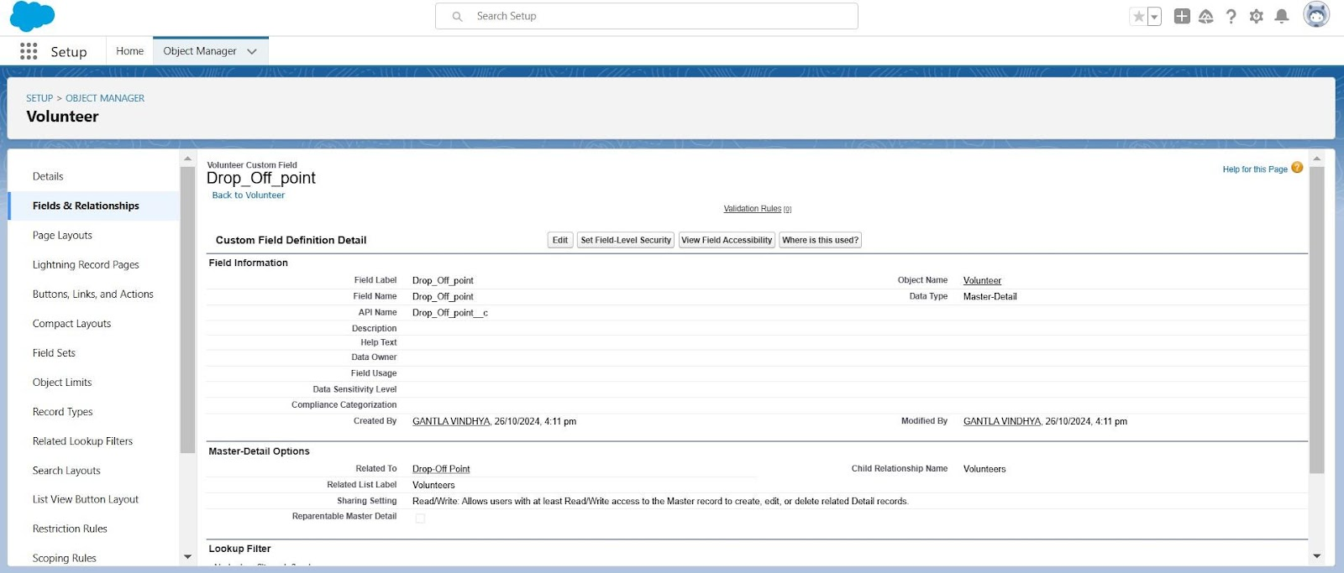

Volunteer ID

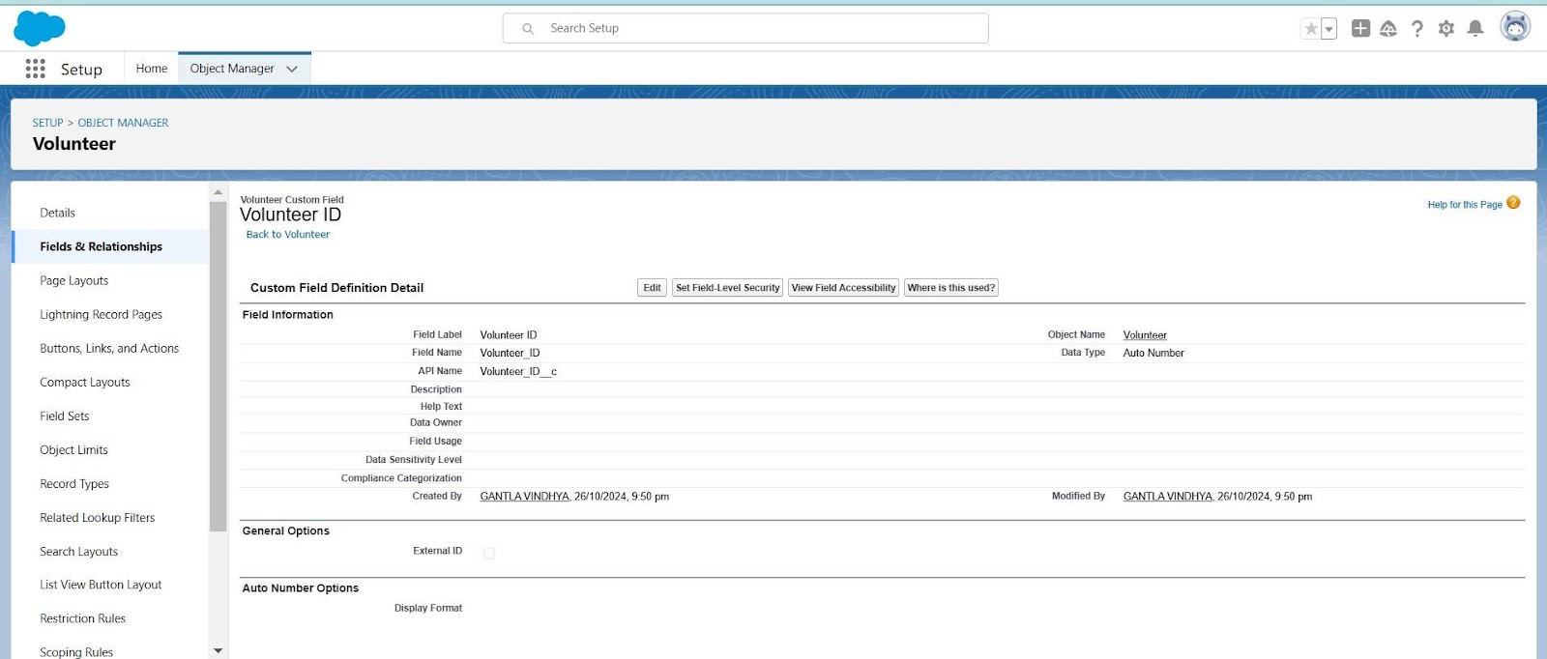

**Creation of Fields for the Venue Object**

Contact Email

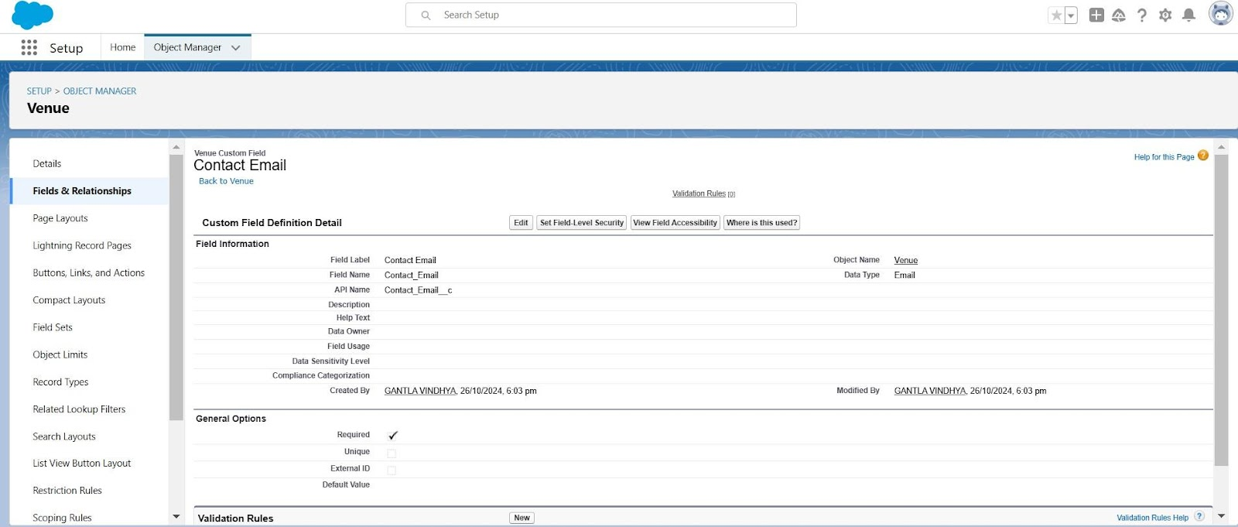

Contact Phone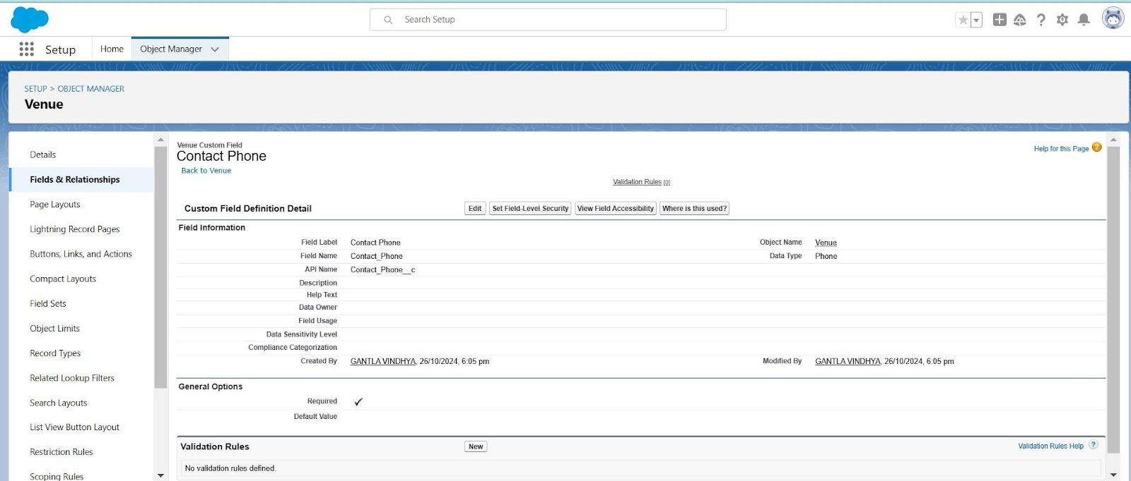

Location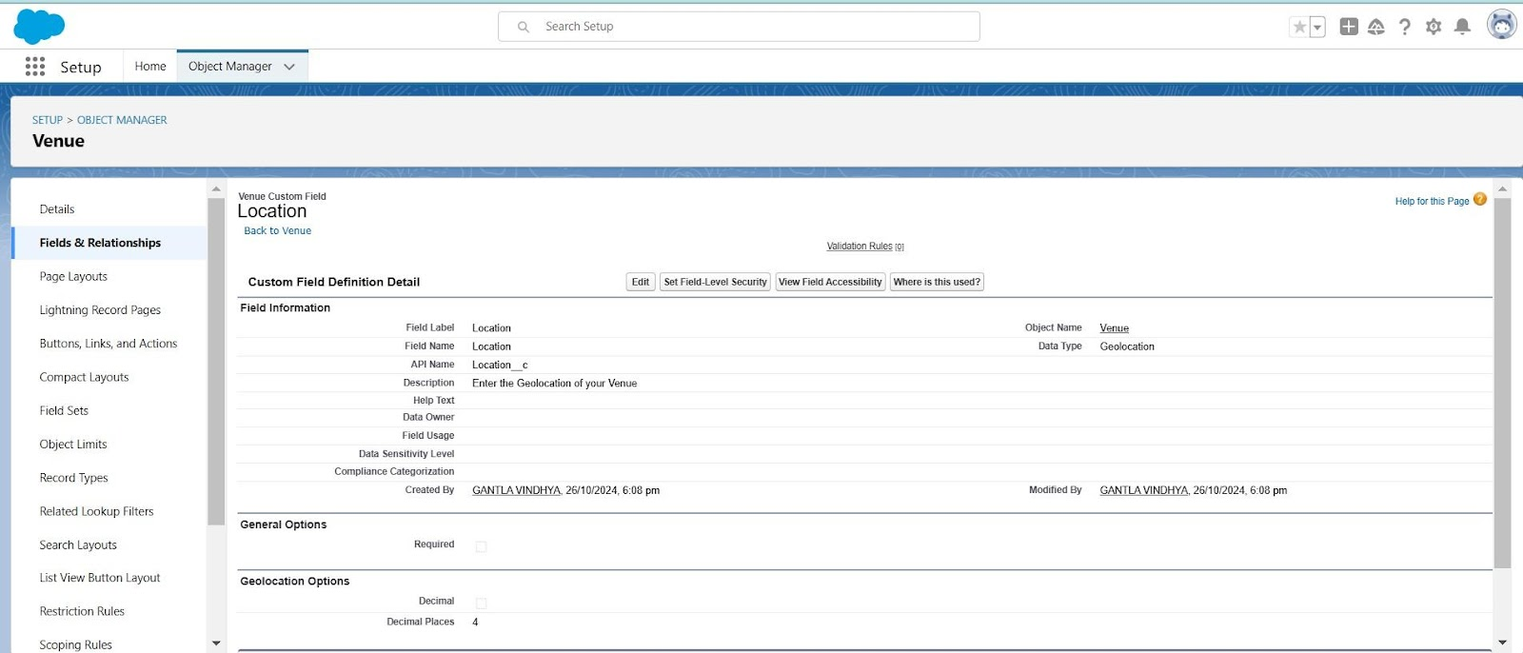

Venue Location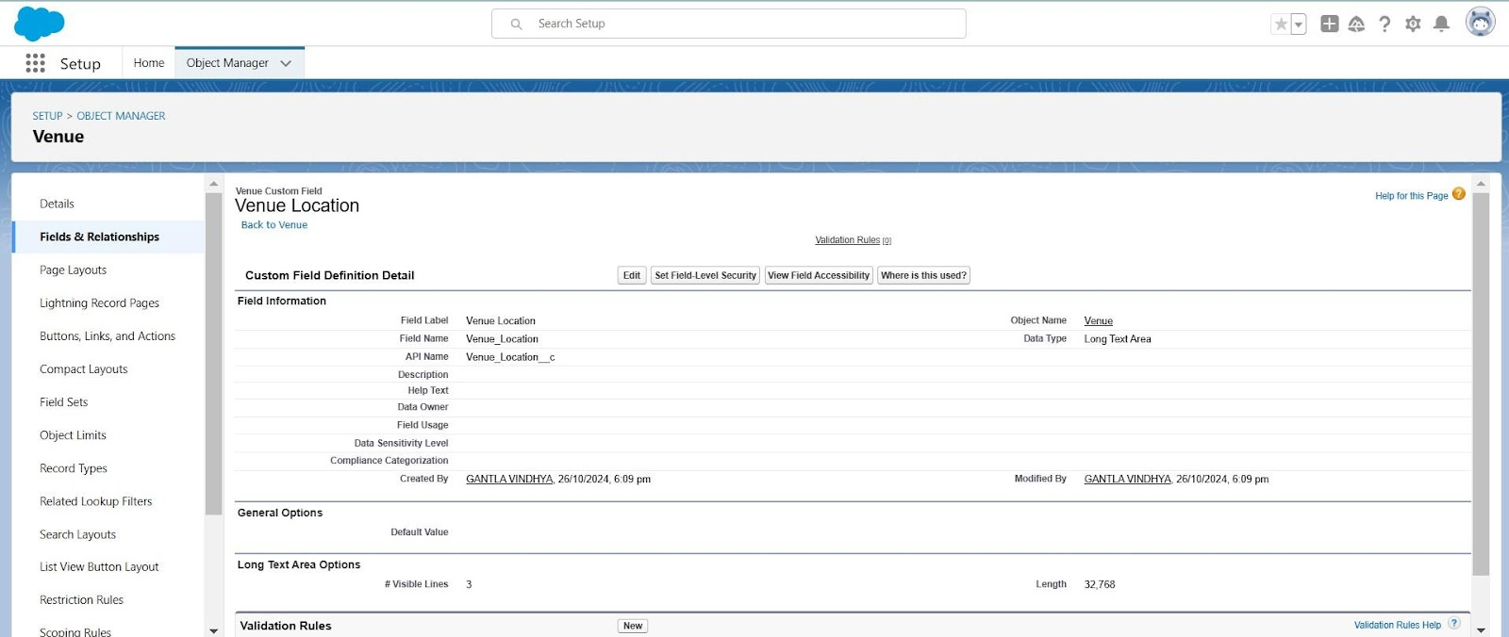

**Creation of Fields for the Drop-Off Point Object**

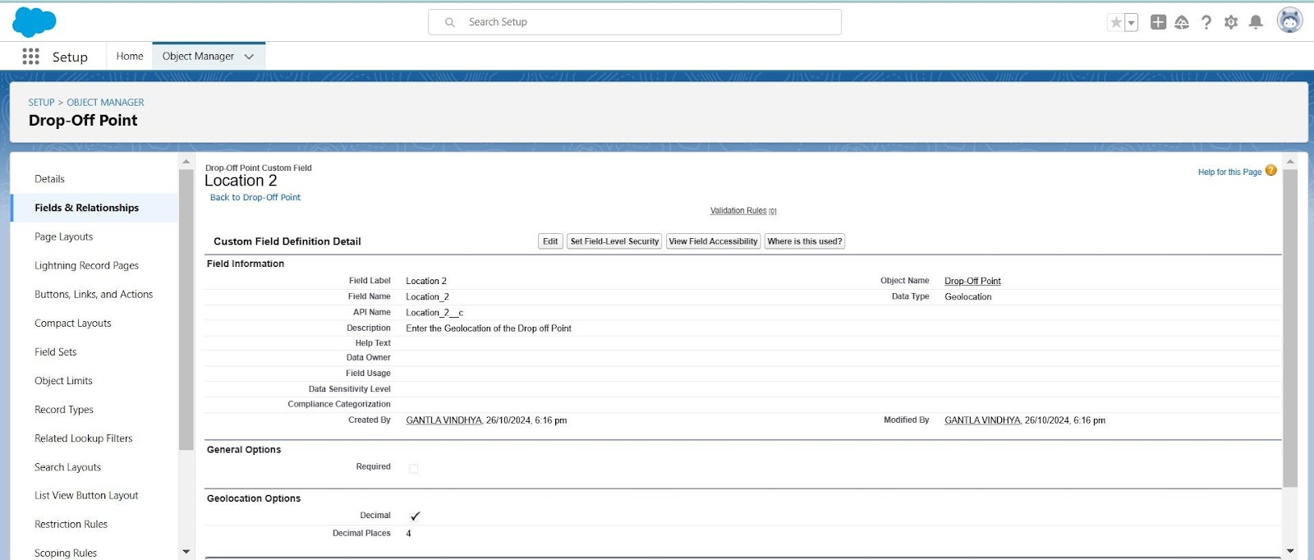Location 2

distance Calculation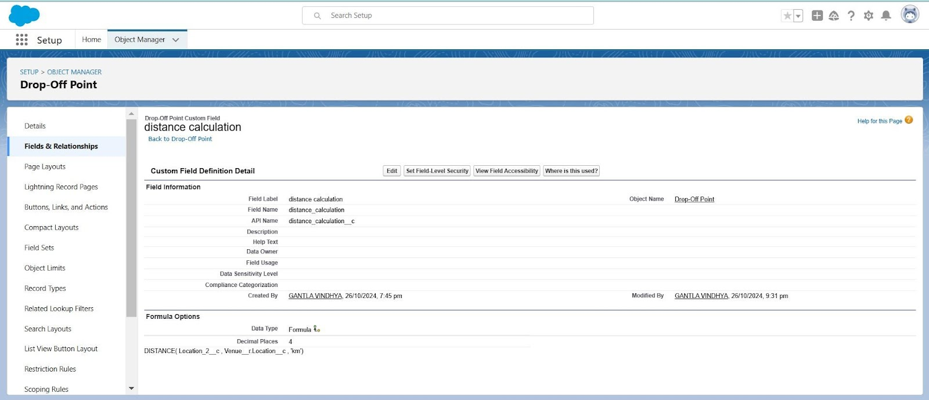

**Creation of Fields for the Task Object**

**Venue_c**

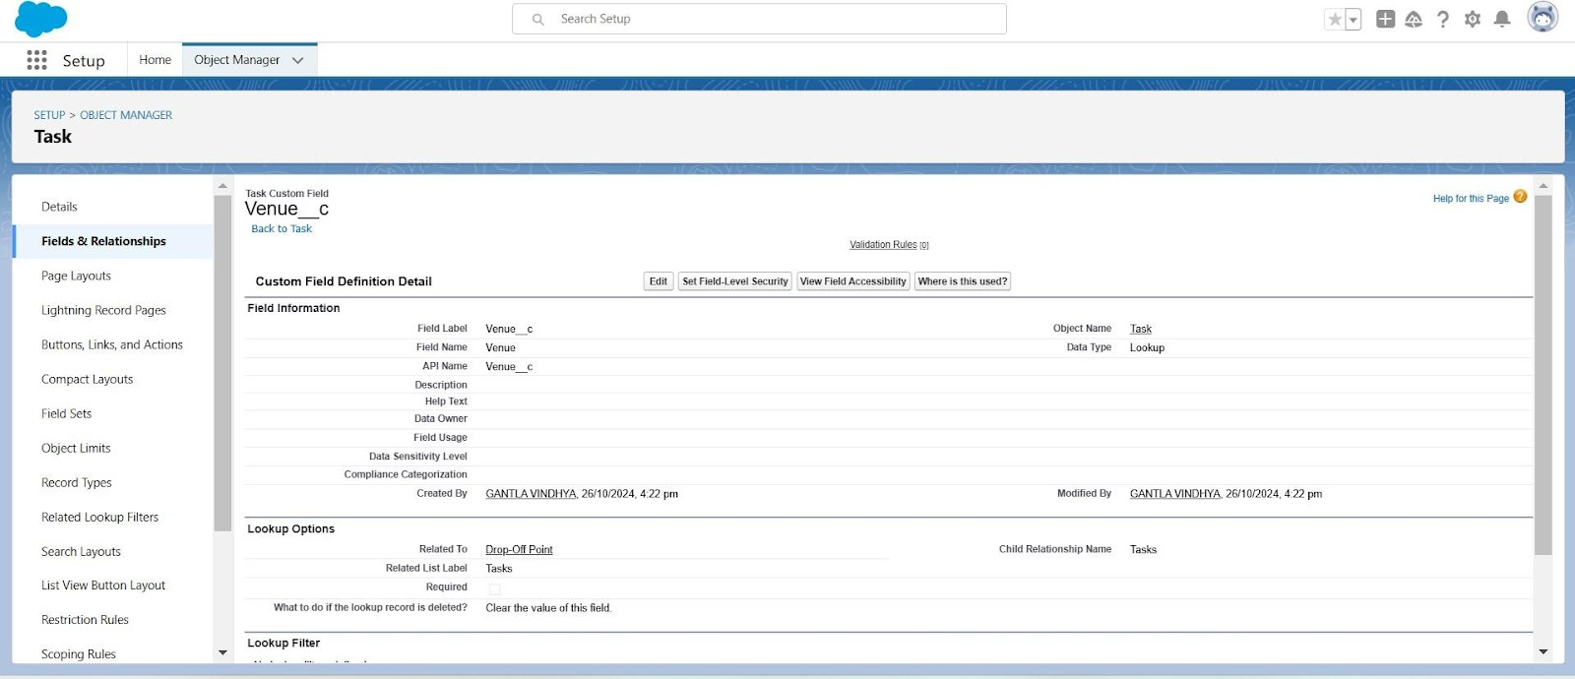

**Feedback**

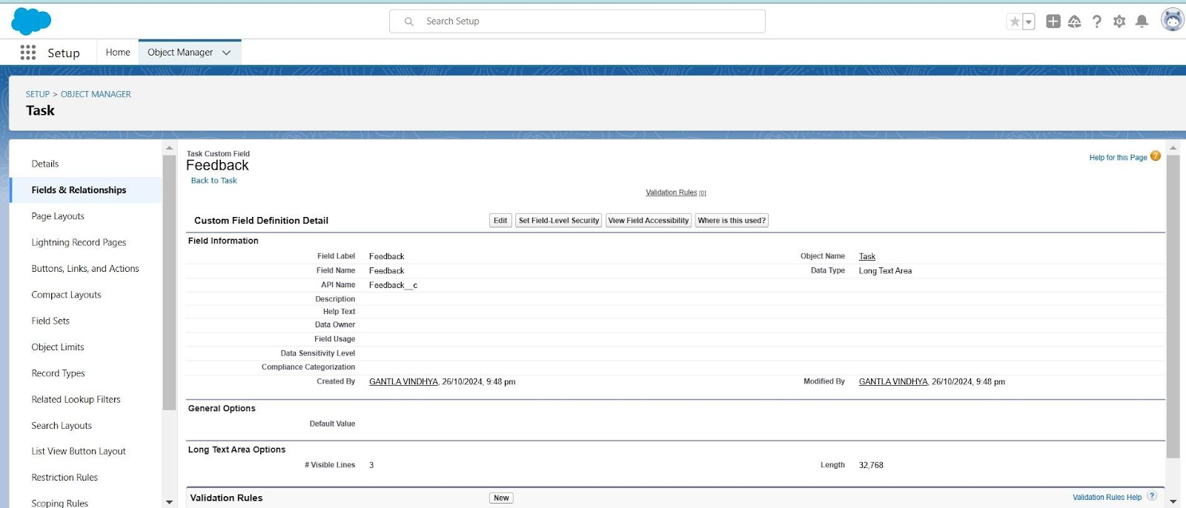

Rating

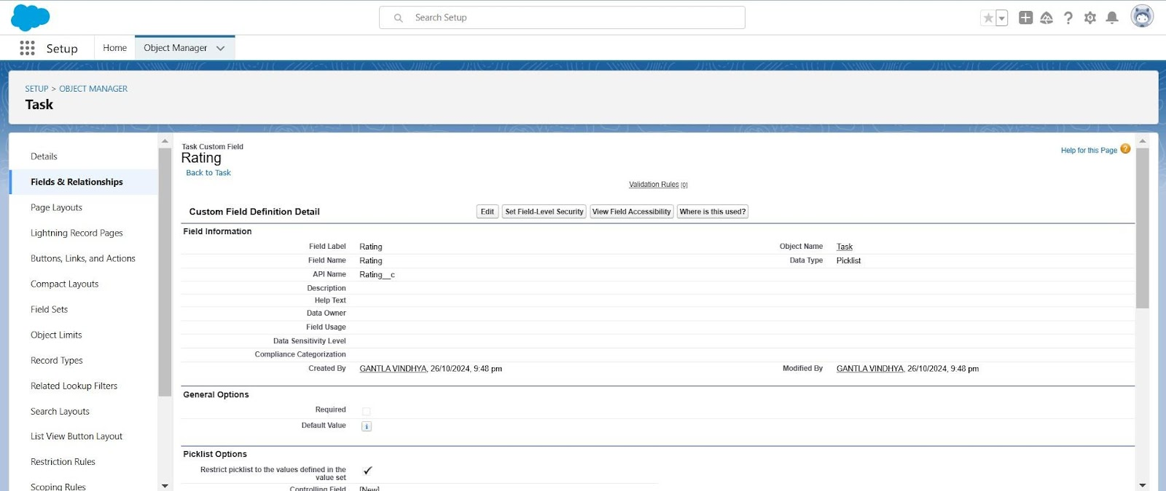

Sponsored By

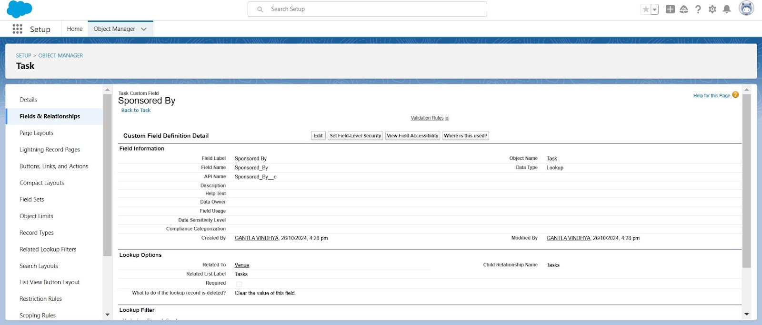

Task Name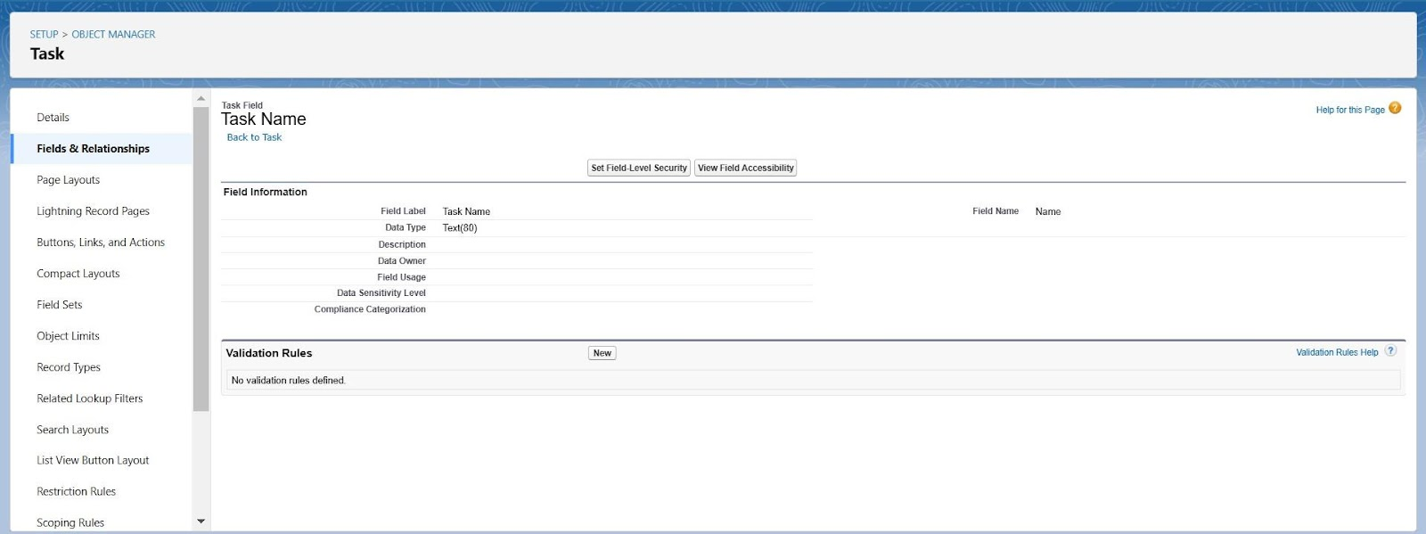

Task ID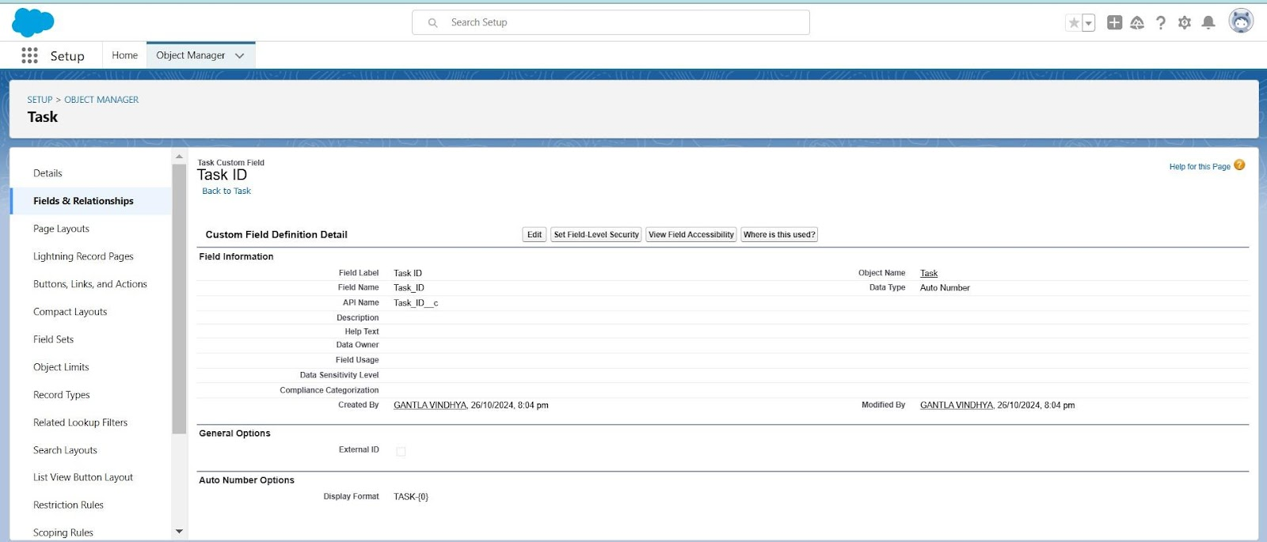

Phone

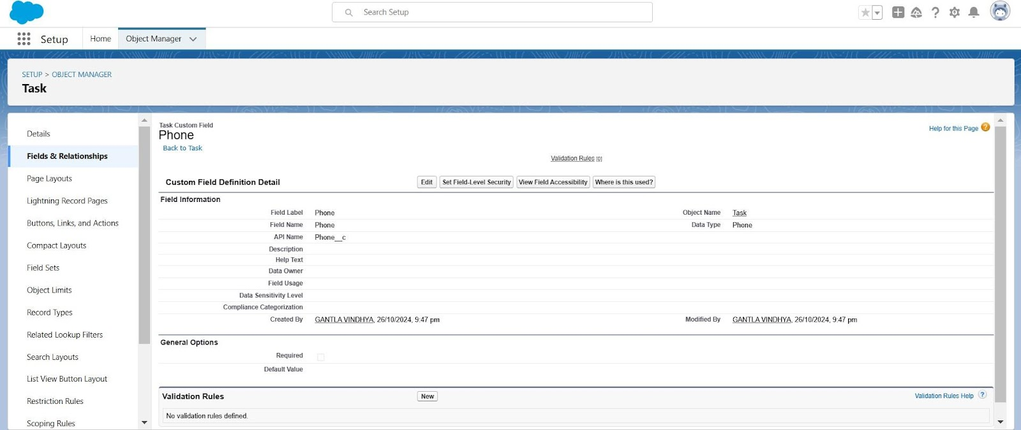

Number of People Served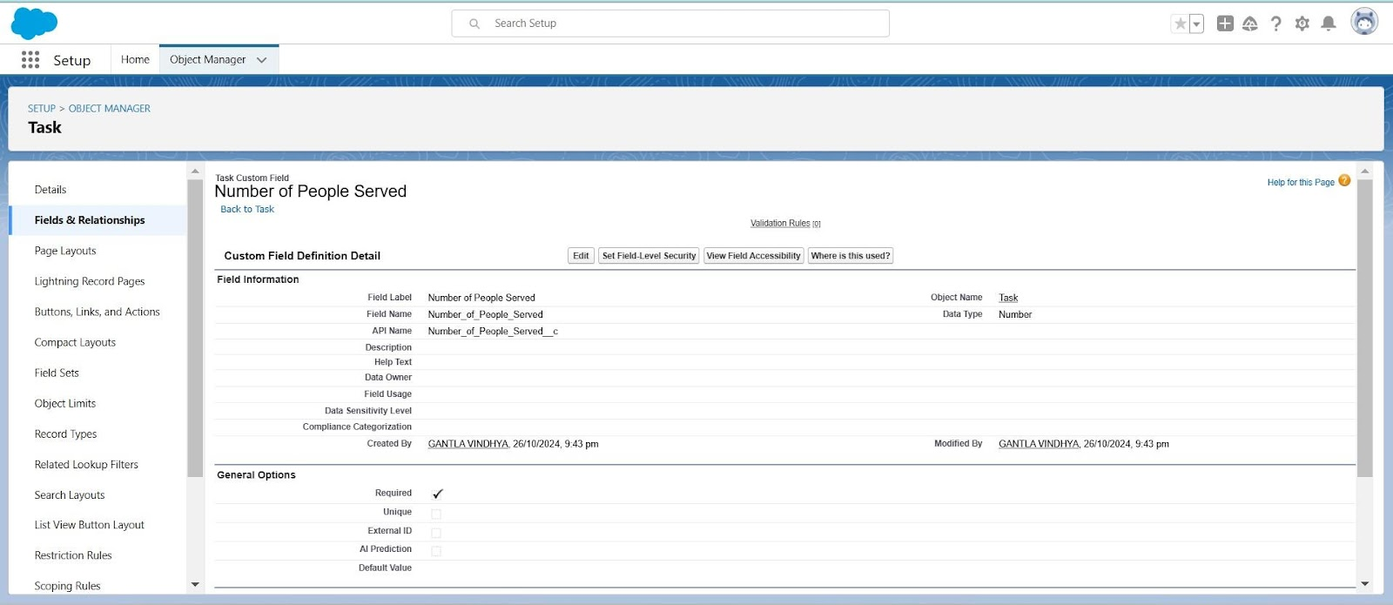

Food Category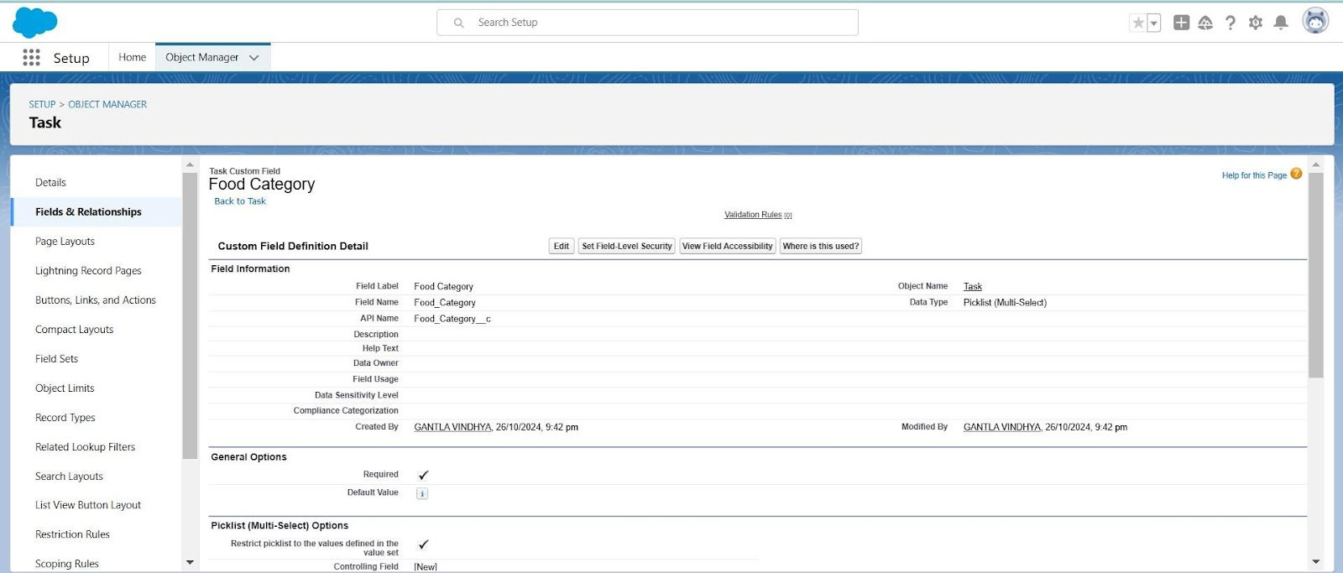

Date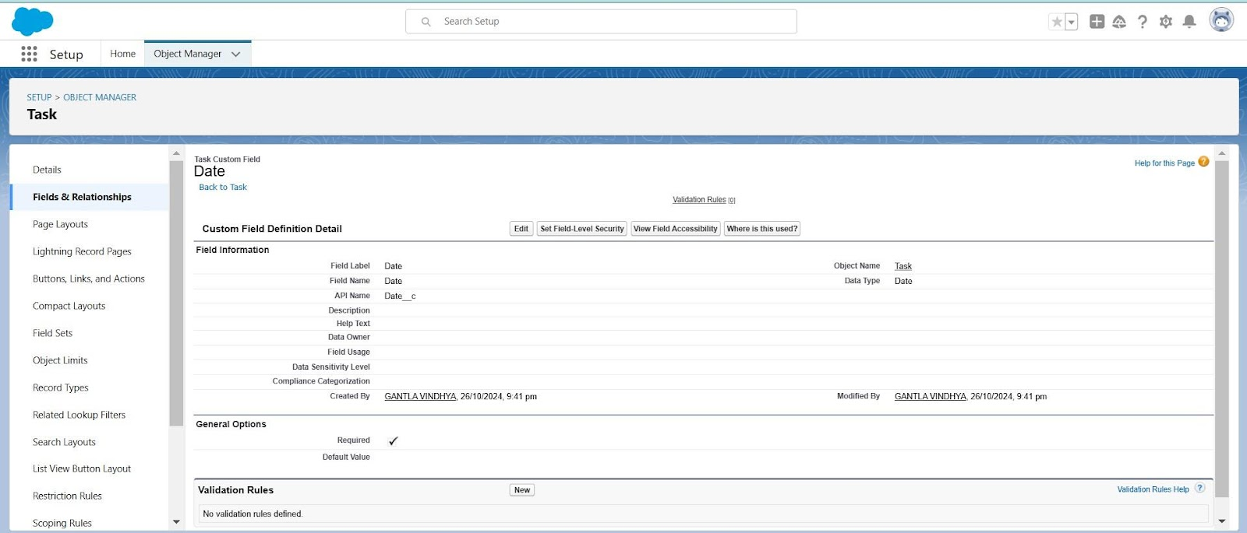

**Creation of Fields for the Execution Details Object**

**Volunteer**

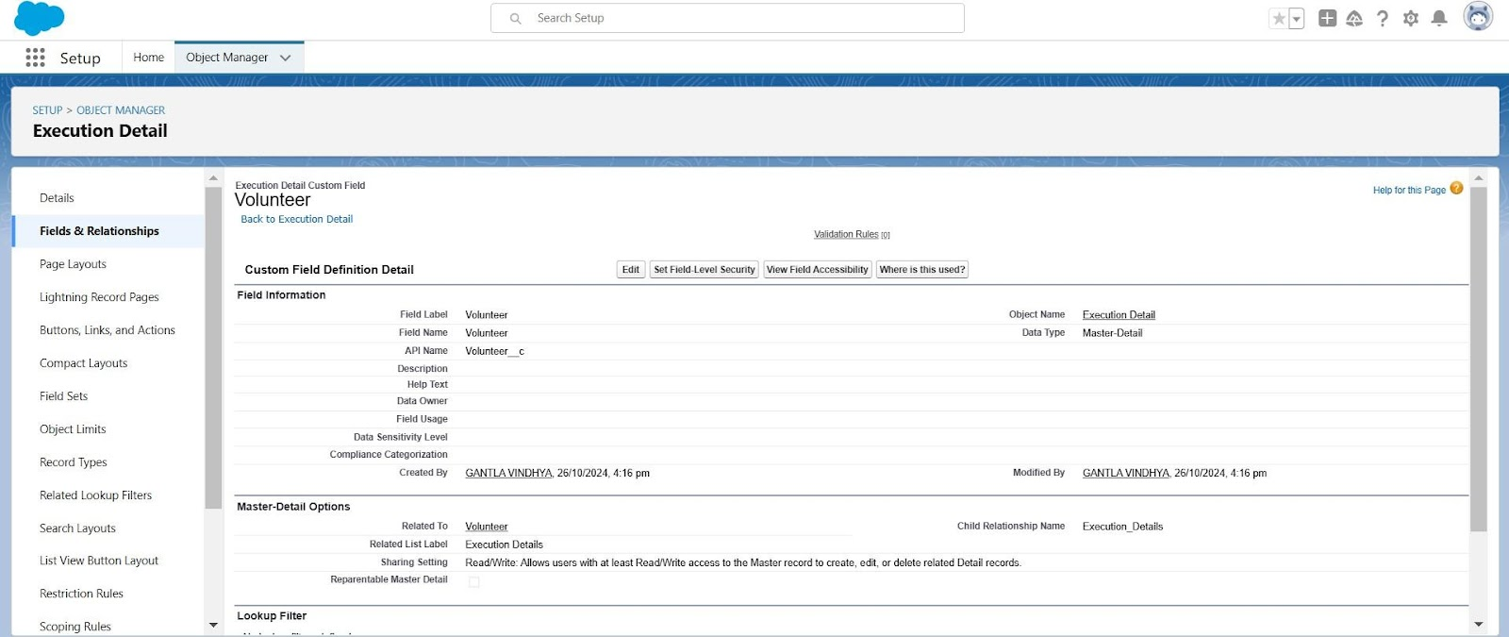

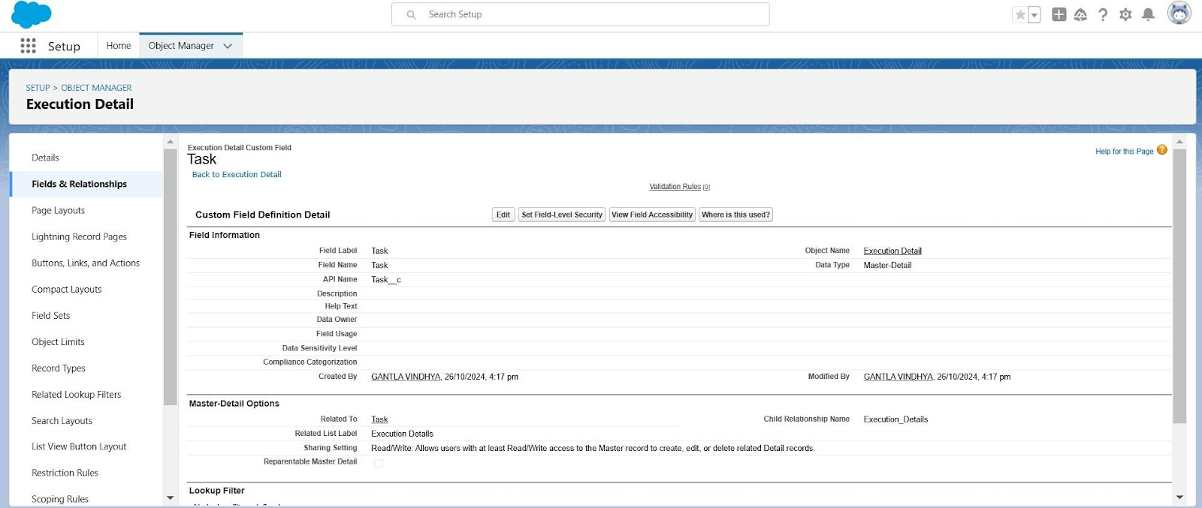Task

**Flows**

**What is a Flow?**

Flows are automation tools that allow users to create complex business processes and workflows using a visual interface. They can automate tasks, guide users through steps, and integrate with other systems.

**Flow to Create a Record in Venue Object**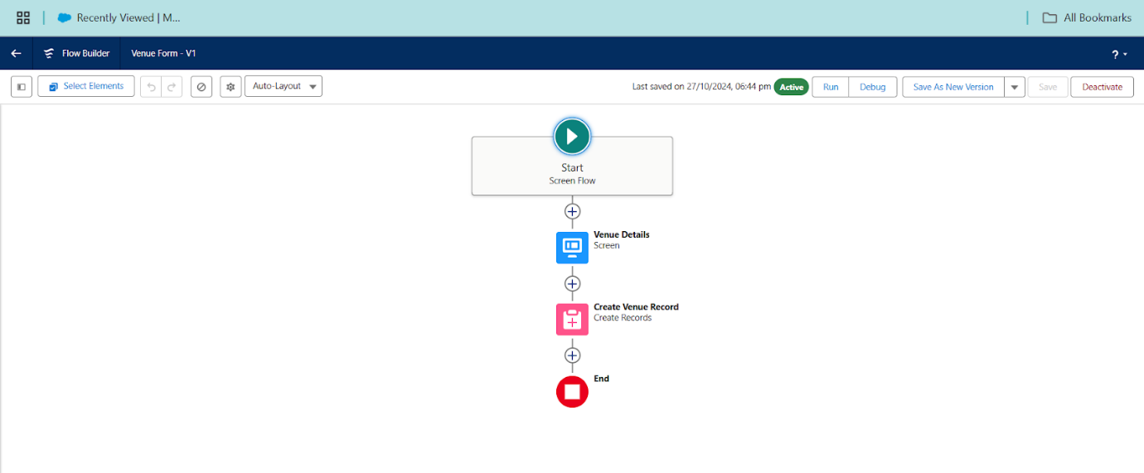

**Trigger**

**What is a Trigger?**

A trigger is a piece of Apex code that executes before or after specific database events on objects, such as insertions, updates, or deletions. Triggers are used to perform custom actions or enforce business rules.

**Trigger Code**

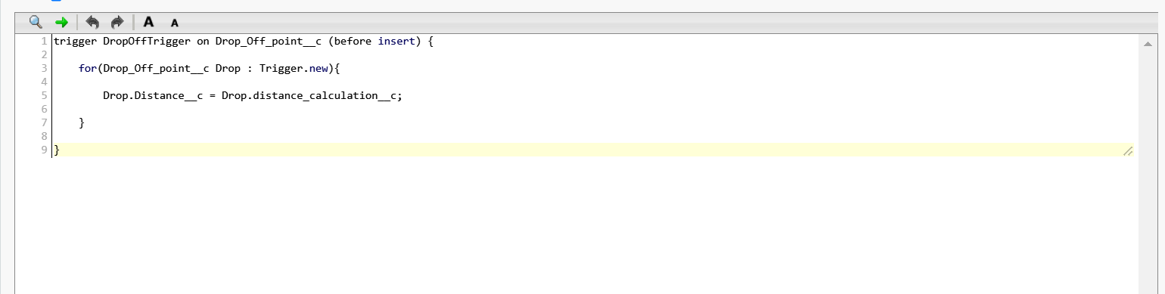

**Profiles**

**What is a Profile?**

Profiles define a user's permissions and access settings, controlling what users can see and do within the application. They specify the objects, fields, and functions a user can access.

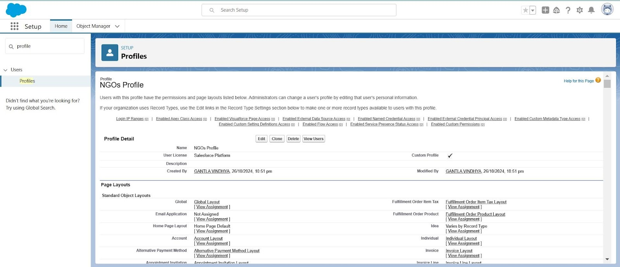

**Users**

**What is a User?**

Users are individuals who have login access to the Salesforce organization. Each user has a unique username, profile, and role, determining their access levels and permissions within the system. Iksha Foundation Iksha

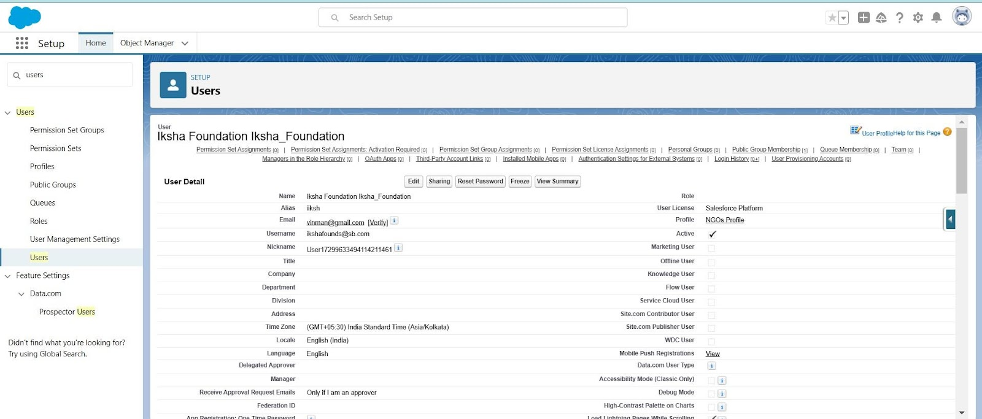

Iksha Founds

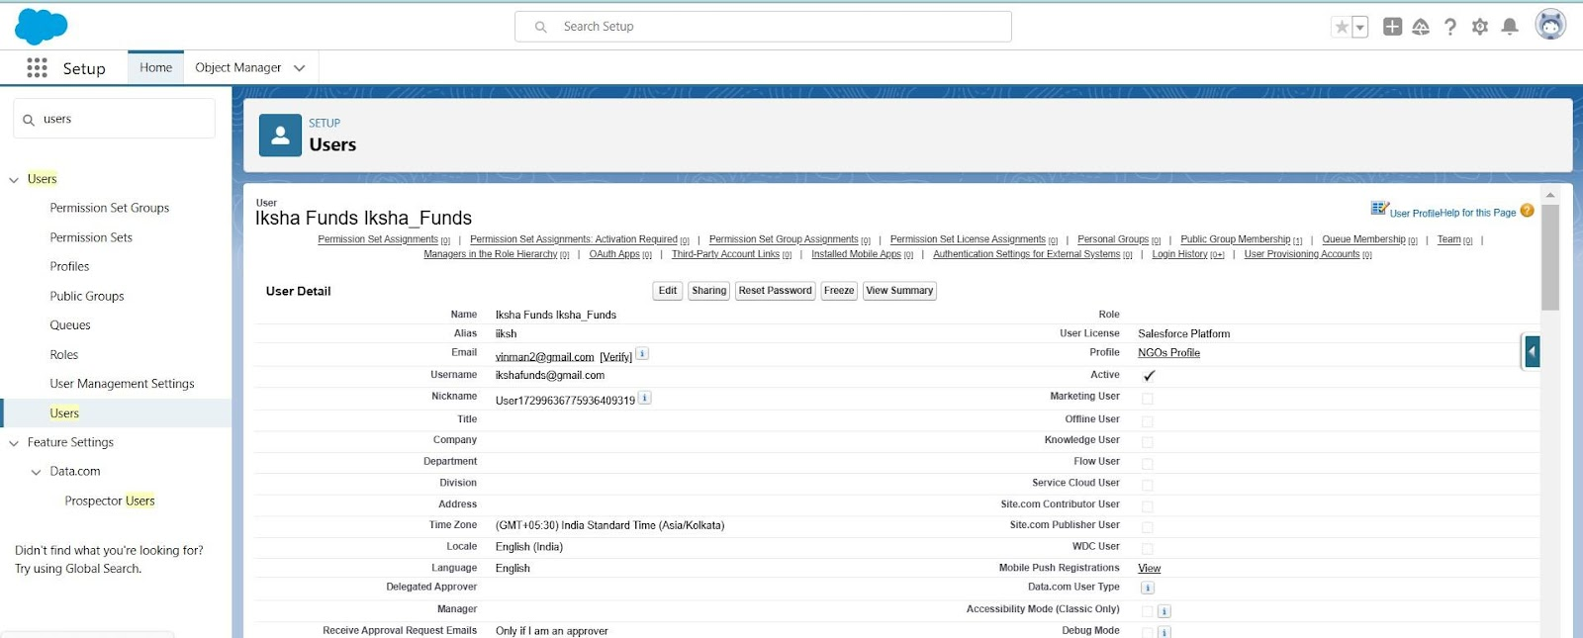

Iksha platform

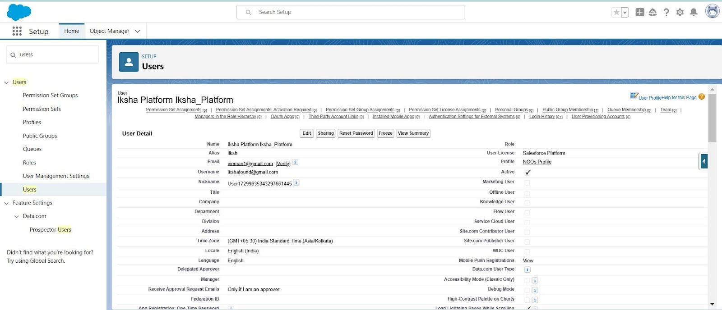

**Public Groups**

**What is a Public Groups?**

Public groups are collections of users, roles, and other groups that can be used to simplify sharing rules and access settings. They help manage data visibility and permissions across multiple users.

**Iksha**

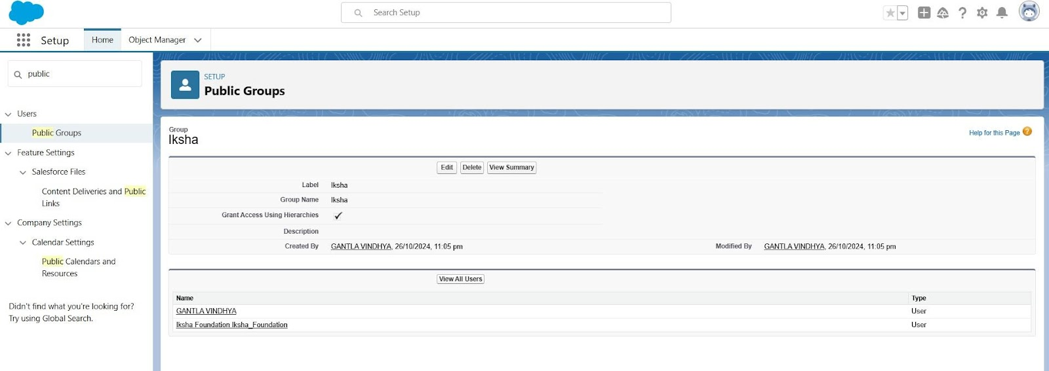

Iksha1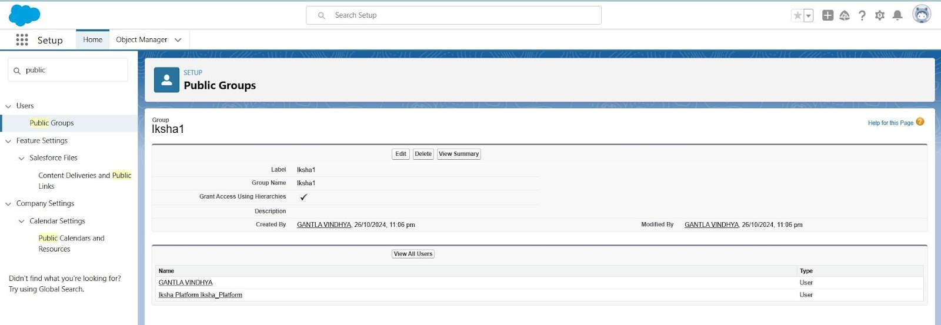

Iksha2

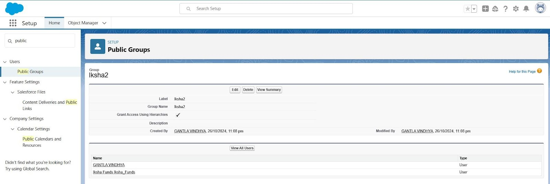

**Report Types**

**What is a Report Type?**

Report types define the set of records and fields available for a report. They determine which objects, and their relationships can be included, allowing users to create customized reports based on specific criteria.

**Venue with DropOff with Volunteer**

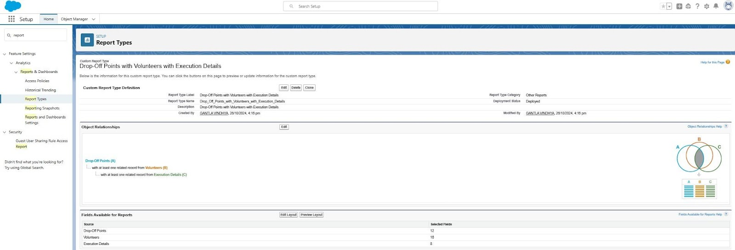

**Dashboards**

**What is a Dashboard?**

Dashboards are visual displays of key metrics and reports, providing a snapshot of business performance. They consist of multiple components like charts, graphs, and tables, offering insights and data visualization for decision-making.

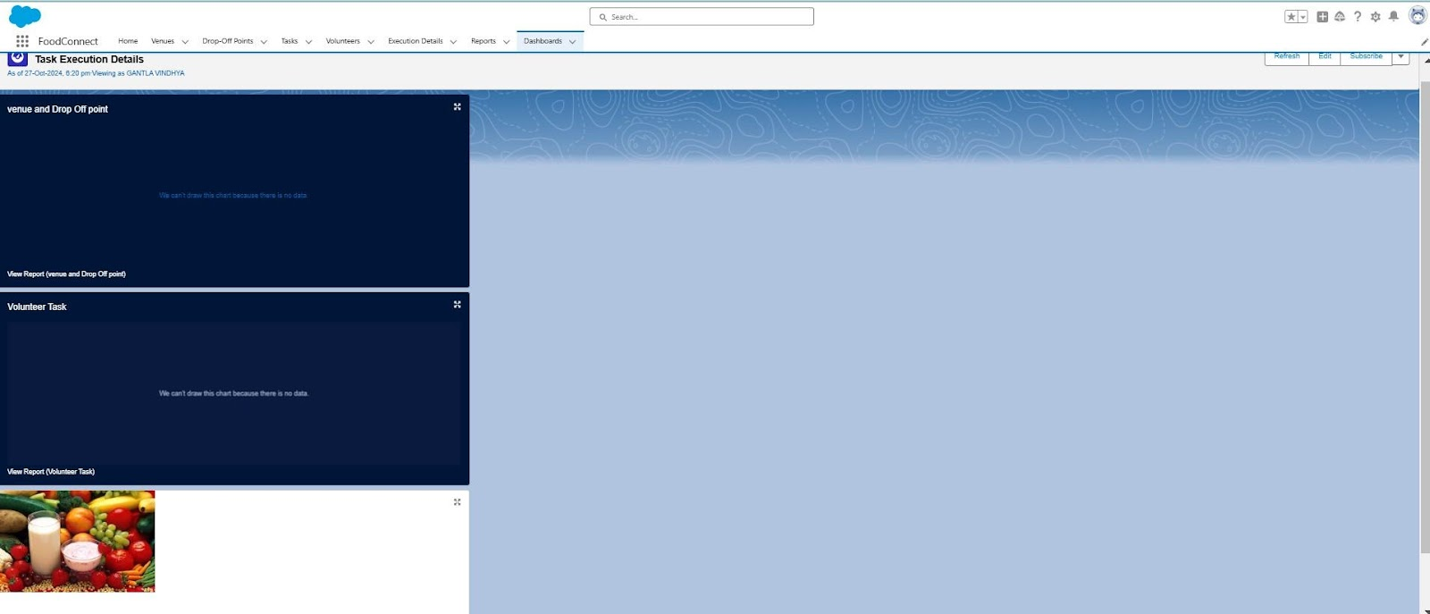

**Sharing Rules**

**What is a Sharing Rule?**

sharing rules are used to extend access to records to users in public groups or roles. They allow administrators to define additional criteria for sharing records beyond what is granted by default through profiles and roles, ensuring appropriate data access across the organization.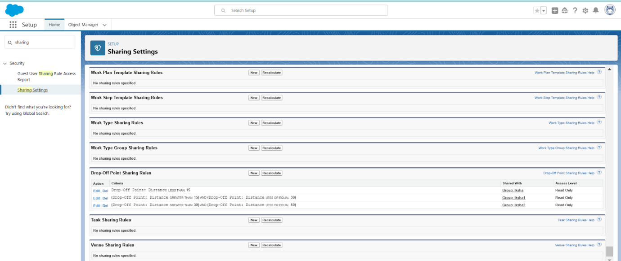

**5. Testing and Validation**

To ensure the system meets quality standards, the following testing methods were applied:

* **Unit Testing**: Verified Apex classes and triggers to ensure business logic functions correctly.
* **User Interface Testing**: Ensured that all user interactions are seamless and align with project objectives.

**6. Key Scenarios Addressed by Salesforce in the Implementation Project**

This project supports multiple use cases, such as:

* **Food Donation Alerts**: Notifies volunteers about new donations.
* **Automated Matching**: Matches donations with recipients based on location and food type.
* **Real-Time Tracking**: Monitors the delivery status for transparency and accountability.
* **Delivery Confirmation**: Confirms that food has reached the intended recipients.

**7. Conclusion**

By leveraging the Salesforce platform, the project successfully established a streamlined and transparent system for managing surplus food donations. Through efficient coordination with volunteers and timely delivery to beneficiaries, the project effectively addressed food insecurity while maximizing the utilization of available resources.

